Yet Another Subnetting Task
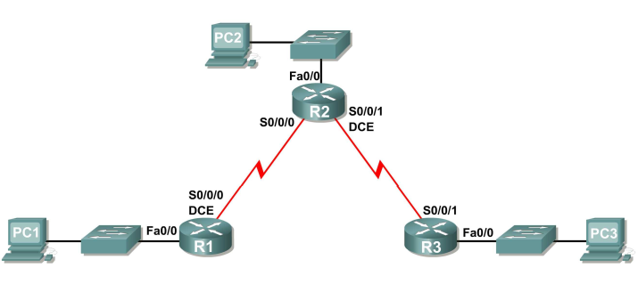
- You have been given the above topology diagram that you need to create. Subnet the network address of 192.168.20.128 with a subnet mask of 255.255.255.128 so that any subnet can have up to 12 useable hosts.
Complete the subnetting exercise and fill in the below table.

Subnet | Network Address | First Useable Host | Last Useable Host | Broadcast Address
R1–R2 – WAN
R2–R3 – WAN
R1 – Fa0/0 – LAN
R2 – Fa0/0 – LAN
R3 – Fa0/0 – LAN

- Set up a new Packet Tracer file and have a go at creating the above topology. You will need to add the WAN interfaces into each router, use a “WIC 2T” interface for each router. This will be new to some of you and so feel free to ask for help.

- Configure all the interfaces with the correct IP addresses. Use the last useable IP address in each subnet for the router interface (this will also be the default gateway for the PC), use the first useable IP address in each subnet for the PC’s interface. Once completed you should be able to ping each router from the PC in the same network.

- If you want a challenge, then see if you can get the WAN links working so that you can ping from router to router. Now how far can you ping from each PC? Why can you not ping any further? If you want a really hard challenge then see if you can work out how to get all interfaces pinging from one end of the topology to the other. This is beyond the scope of CCNA1 and is more of a fun challenge and so don’t worry if you cannot do this.

